Lab 7 Client side and web attacks
Install tiny 11

Meterpreter Backdoor
Create payload to exploit windows client
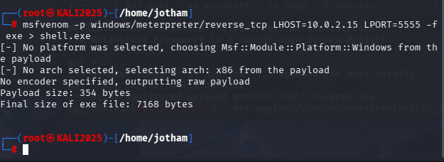
- Created in /home/Jotham directory

Copy payload into folder accessible via Kali Apache HTTP webserver
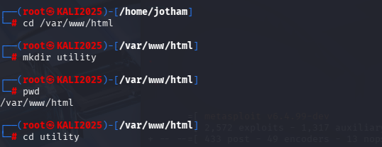
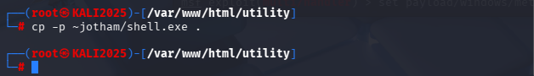
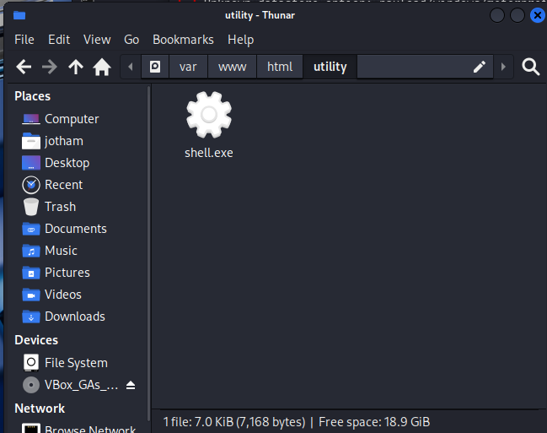

Start the kali webserver
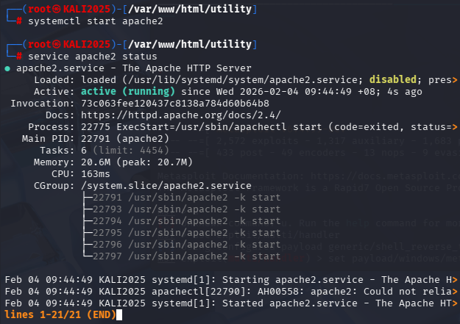

Run Metaexploit
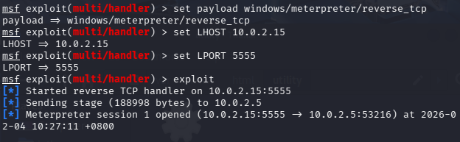

Victim downloads Shell.exe from Kali’s website and executes it
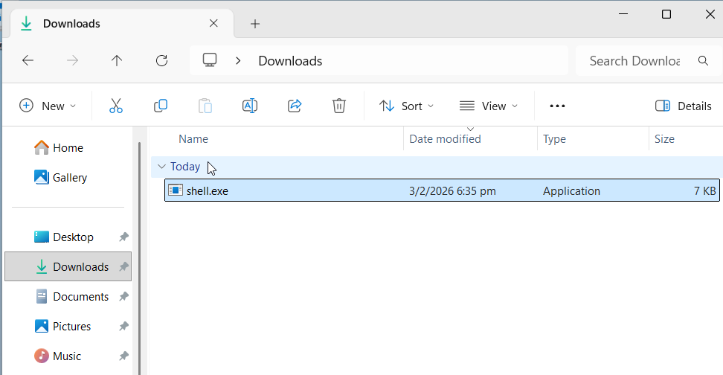

Exploited
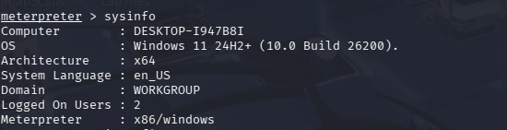
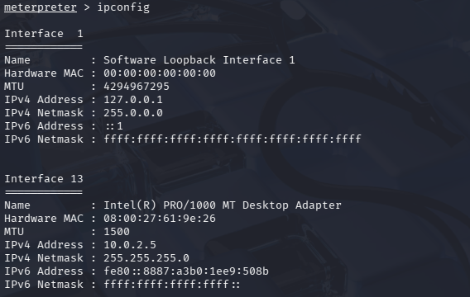

Use Keylogger to capture victim’s input

Start the keylogger
keyscan_start
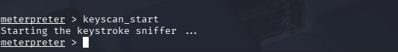

User type in input
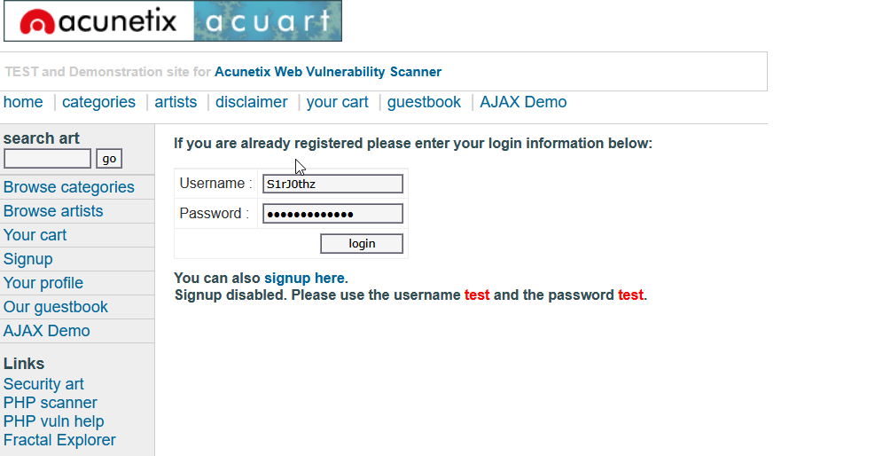

Show Key logger output
keyscan_dump
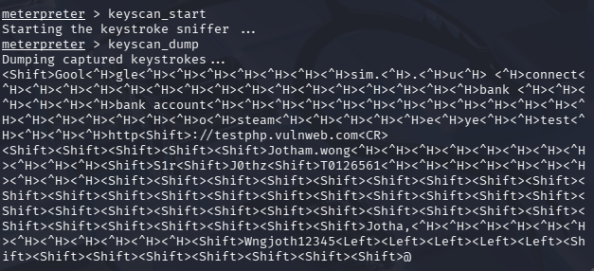
Username: S1rJ0thz
password: Wngjoth12345

Stop key logger
keyscan_stop
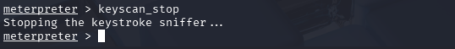

Command Execution Vulnerability
Go to the Damn Vulnerable Web Application (DVWA) and login
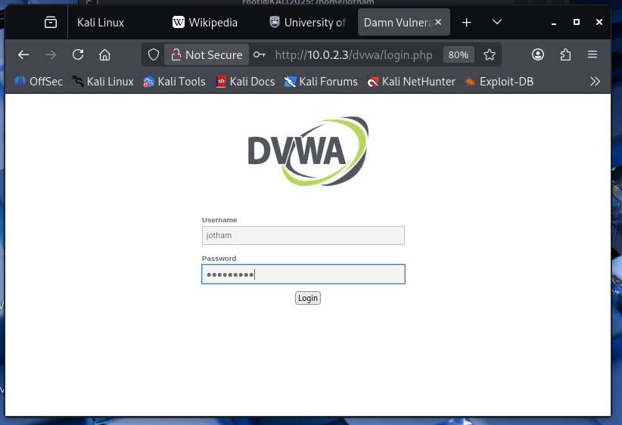
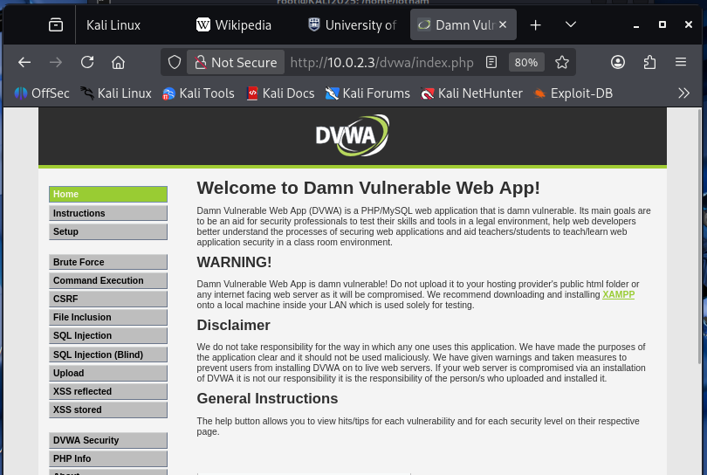

Inject Script into Application’s input field to create reverse shell using netcat
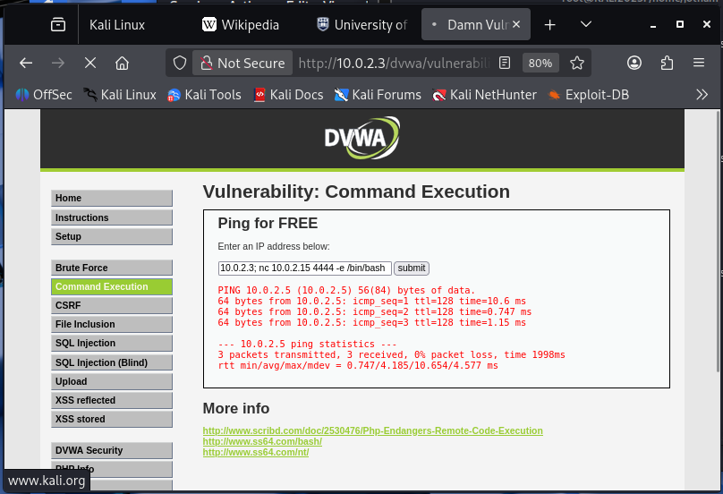

Listen on port 4444
